Expression of Interest (EOI) and Guidelines for the Submission of Quotations for the Procurement of Educational Packages/Materials for Distribution to Approximately 22,000 Targeted Beneficiaries Across Good Neighbors Bangladesh's Designated Urban and Rural Project Areas.

[Details description of the Items/Products]
S.L | Description of Items or Technical Specification | Regular Unit Price (MRP) | Offer Rate/ Unit Price | Demo Picture | Remarks
1 | Technical Specification of Norte Book/Khata:  - Paper: 70gsm Bashundhara  - Size: Demy Size (8.75” ×11”)  - Total Page: 120 page (60 leaf’s) without cover  - Inner page: Roll as per design (like math and Bangla Khata)  - Cover: 300gm art board 4 color print front and back cover pages and inner 4 color print (no lamination)  - Cover page Design: As per design.  - Bindings: Glue and Stiches (Juice Bindings). |  |  | 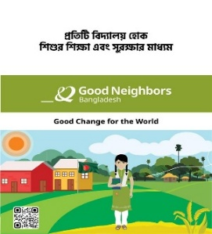  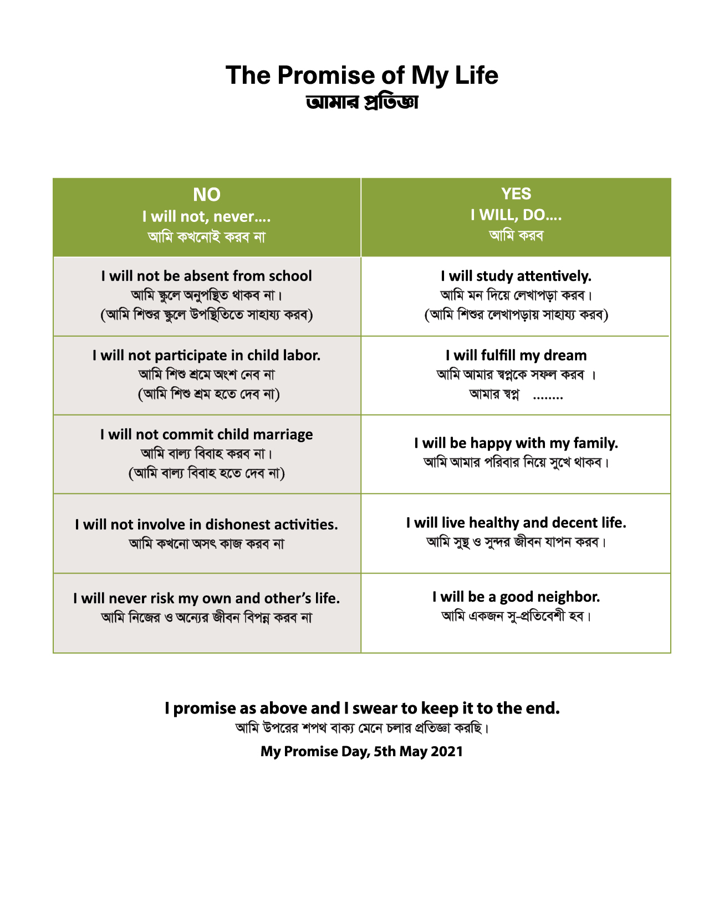 | This is the cover and back page picture  [Approximate Quantity: 1,05,000 units (subject to change based on actual requirements)]
2 | Technical Specification of Ballpoint pen:  - Type: Oil-based ink ballpoint pen  - Tip Size: 0.6 mm Nickel Silver (NS) tip with a Tungsten Carbide (TC) ball  - Writing Performance: Smooth, consistent, and smudge-free writing with uninterrupted ink flow  - Body Material: Durable plastic barrel with a matte or glossy finish  - Grip: Soft rubber grip for comfortable handling and improved writing control  - Ink Color: Only Black  - Quality: High-quality, durable, and suitable for regular educational use  - Packaging: As per required  - Logo Printing: GNB logo shall be clearly and permanently printed on the pen barrel using a durable printing method that does not fade or peel off during normal use. |  |  |  | [Approximate Quantity: 1,05,000 units (subject to change based on actual requirements)]
3 | Technical Specification of Geometry Box:  (Geometry Box Mathematical Instruments Set)  - Product type: Mathematical Geometry Set  - Brand: Good Luck Stationery (RFL)  - Model: RFS00304  - With organizational logo 4 color permanent print  - Geometric tools set: Compass, Divider, Pencil, set square 45°, Set square 60°, Protector 180°, Ruler 15cm, Sharpener, Eraser  - Heavy duty smart fashionable compass and divider.  - Ergonomic and east to use and High precision |  |  | 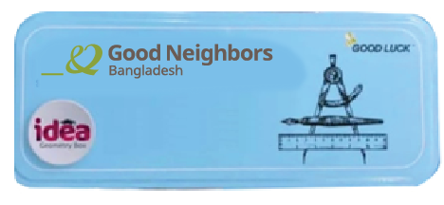 | [Approximate Quantity: 6,200 units (subject to change based on actual requirements)]
4 | Technical Specification of School Bag:  - Product Type: School Bag  - Size: Height 18", Length 12.5", Width 7.5"  - Quality: 100% Good quality  - Material: High-quality, durable polyester or nylon fabric with a water-resistant coating  - Color: Body Black and olive green as approved by GNB  - Compartments: Minimum two (2) spacious main compartments and one (1) front zippered pocket  - Shoulder Straps: Adjustable, padded, and ergonomically designed for comfortable carrying  - Back Panel: Padded back support for enhanced comfort (preferred)  - Handle: Strong, reinforced top carry handle  - Zippers: Heavy-duty, durable zippers with high-quality zipper pullers  - Stitching: Double-stitched and reinforced at all stress points to ensure long-lasting durability  - Logo: GNB logo shall be clearly and permanently embroidered or rubber printed on the front panel using a durable method that does not fade, peel, or crack under normal use.  - Design: Child-friendly, lightweight, and suitable for daily school use  - Quality: High-quality workmanship with a durable finish, suitable for regular use by school students  - Packaging: Individually packed in a transparent polybag or equivalent protective packaging (if required) |  |  | 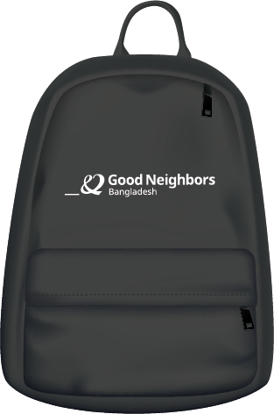 | [Approximate Quantity: 6,200 units (subject to change based on actual requirements)]
5 | Technical Specifications of Umbrella:  - Type: Folding Umbrella  - Size: 42-inch canopy (open diameter)  - Canopy Material: High-quality double-layer polyester fabric with 100% water-resistant coating  - Color: Black and approved by Good Neighbors Bangladesh  - Frame Material: Durable aluminum alloy and steel frame  - Ribs: 12 reinforced ribs (spokes) for enhanced strength and wind resistance  - Handle: Ergonomic plastic or rubber-coated handle for a comfortable grip  - Opening Mechanism: Manual or automatic open (as specified by GNB)  - Quality: Strong, lightweight, wind-resistant, and suitable for daily use  - Logo: GNB logo shall be clearly and permanently printed on one or more umbrella panels using a durable printing method that does not fade, peel, or crack during normal use.  - Packaging: Individually packed in a protective polybag. |  |  | 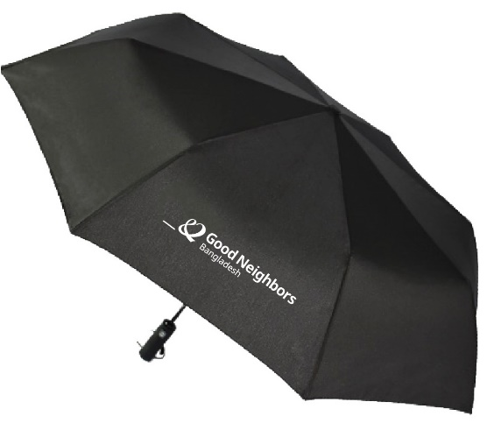 | [Approximate Quantity: 6,200 units (subject to change based on actual requirements)]
 | Technical Specifications – Water Bottle:  - Type: Reusable School Water Bottle  - Capacity: Minimum 500 ml  - Material: Food-grade, BPA-free, non-toxic plastic  - Colour: As approved by GNB  - Design: Lightweight, child-friendly, and ergonomically designed for easy handling  - Cap: Leak-proof screw cap or flip-top cap with secure locking mechanism  - Mouth Opening: Wide-mouth design for easy filling, drinking, and cleaning  - Durability: Strong, impact-resistant, reusable, and suitable for daily school use  - Safety: Odour-free, tasteless, and compliant with applicable food safety standards  - Logo: GNB logo shall be clearly and permanently printed or engraved on the bottle using a durable method that does not fade, peel, or wear off during normal use.  - Quality: High-quality finish with smooth edges and free from manufacturing defects  - Packaging: Individually packed in a protective polybag or manufacturer's original packaging |  |  |  | [Approximate Quantity: 6,200 units (subject to change based on actual requirements)]
PSEA Issue: GNB maintains zero tolerance approach for all forms of sexual exploitation and abuse (PSEA). Stakeholders must be concerned about issues such as child rights, PSEA, and safety. If any of the stakeholders violates the PSEA policy, a child rights issue, or a safety issue, GNB has the right to terminate the contract immediately.

Express of Interest (EOI) information
Name of the Organization/Company
Address
Primary Contact Person for this EOI | Name:
Primary Contact Person for this EOI | Contact Number:
Primary Contact Person for this EOI | Email:
Nature of the Organization/Company (e.g. Business, Group of Company, A Trust, A sister concern of a group of Company)
VAT Registration No (Attach copy)
TIN Registration No (Attach Copy)
BIN No (Attach Copy)
Trade license/Business Permit (Attach copy)
Our company is committed to complete the supply of the mentioned items (furniture) within the time frame by submitting the quoted amount excluding/including VAT and also the transportation facilities.
Date
Represented by
Signature
Stamp/Seal

